**Practical No - 12**

**Aim** : Clustering Analysis.

**Solution** : we will use customer data [6] that is contained in “customers.arff” file and analyze it with k-means clustering scheme.

We have to create excel file

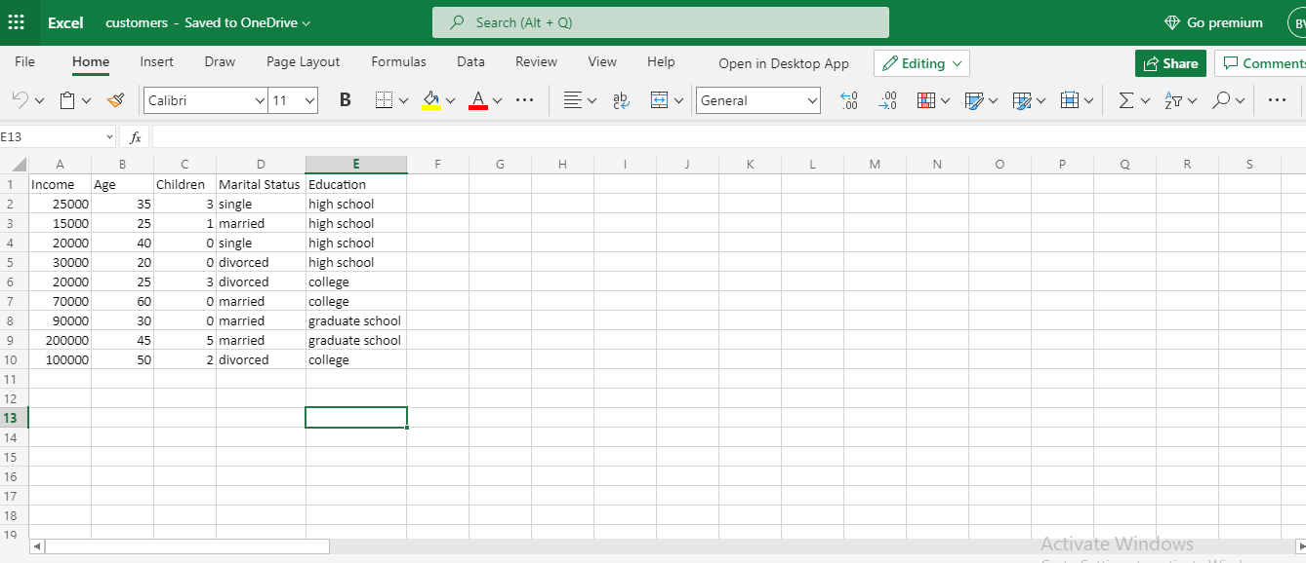

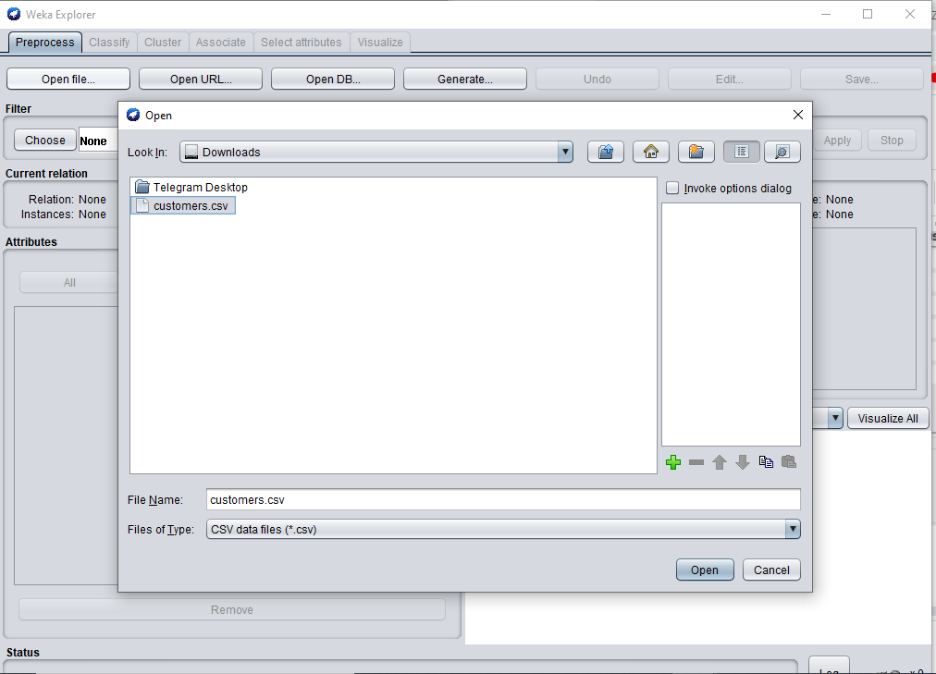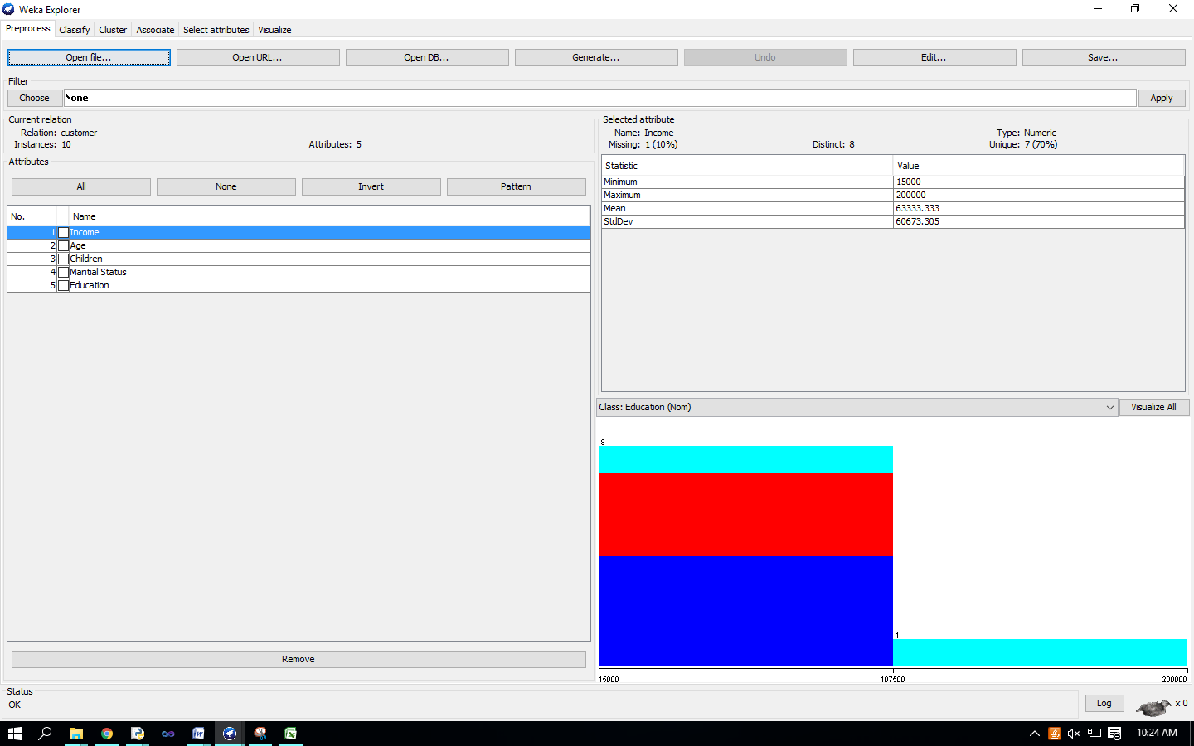 In ‘Preprocess’ window click on ‘Open file…’ button and select “customers.arff” file. Click ‘Cluster’ tab at the top of WEKA Explorer window.

In the ‘Clusterer’ box click on ‘Choose’ button. In pull-down menu select WEKA   Clusterers, and select the cluster scheme ‘SimpleKMeans’. Some implementations of K-means only allow numerical values for attributes. right-click on the algorithm “weak.gui.GenericObjectEditor” comes up to the screen. 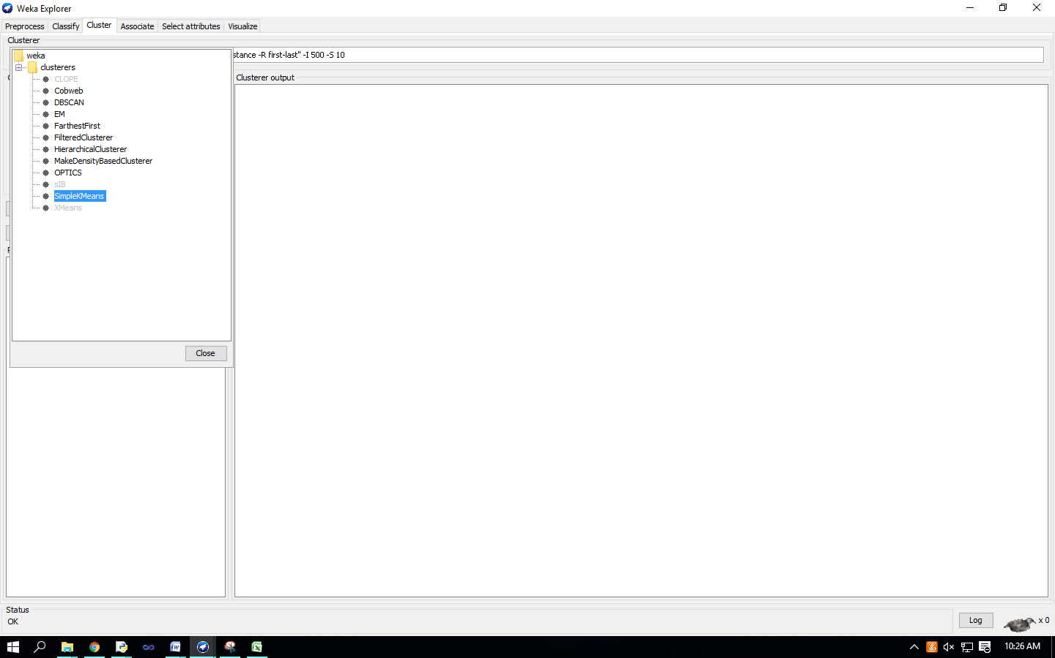Set the value in “numClusters” box to 5(instead of default 2) because you have five clusters in your .arff file.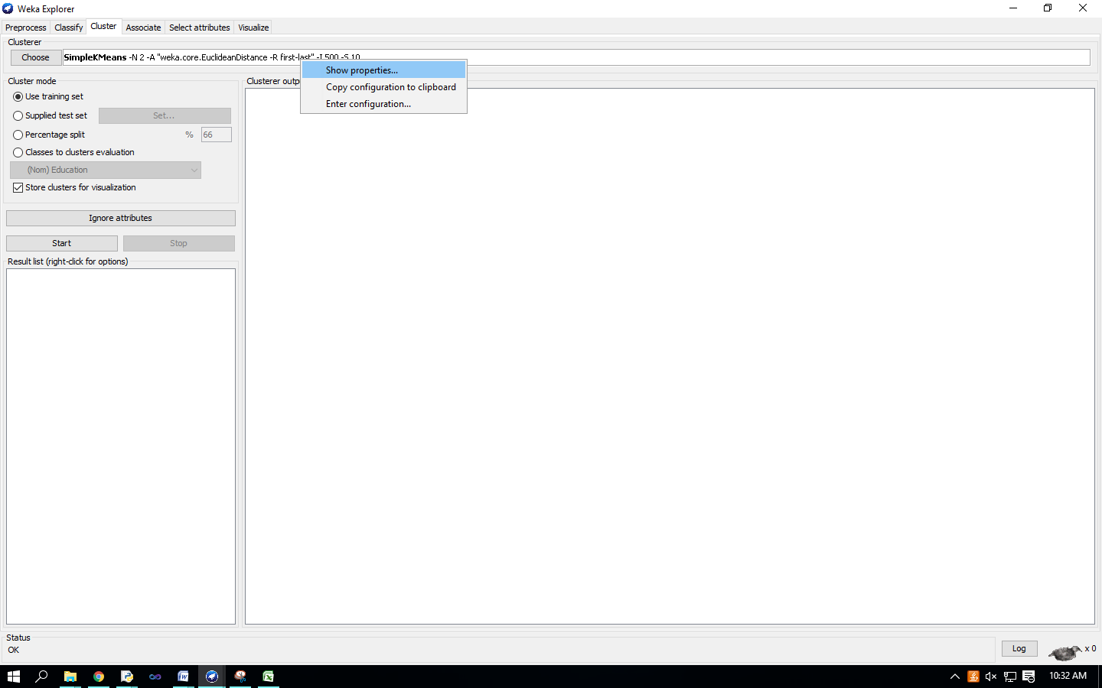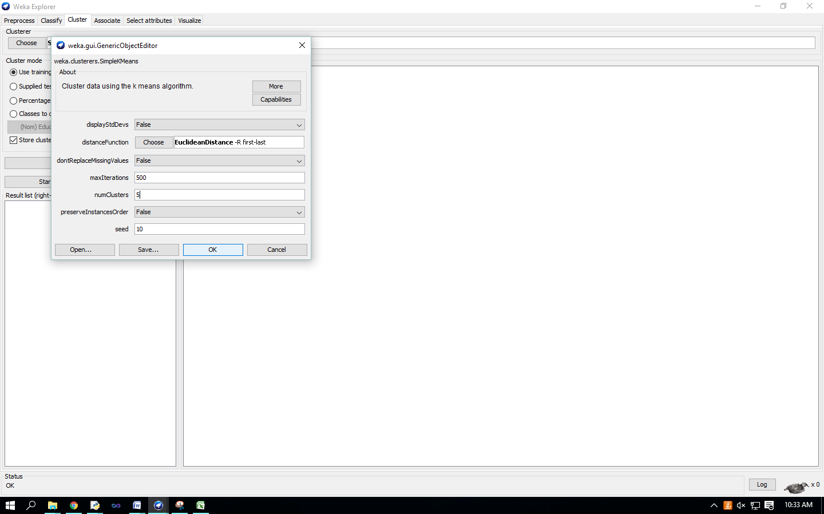 Click on ‘Classes to cluster evaluation’ radio-button in ‘Cluster mode’ box and select ‘marital_status’ in the pull-down box below. 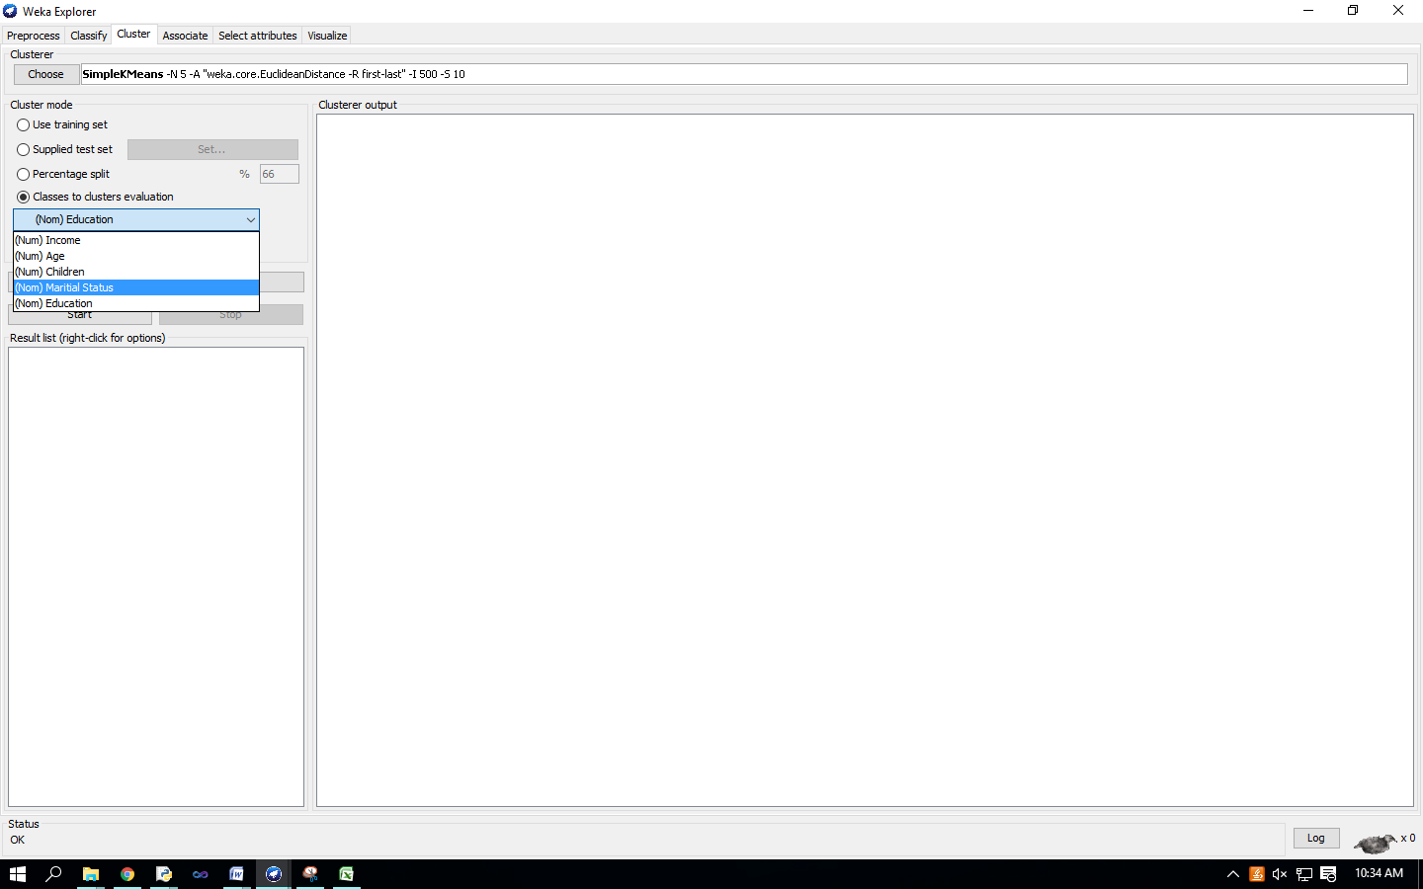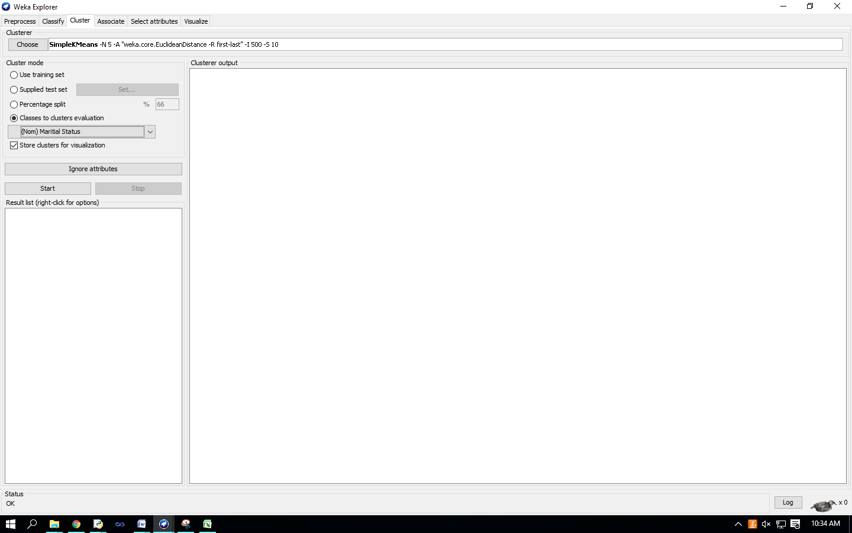 Click on the ‘Start’ button to execute the algorithm. 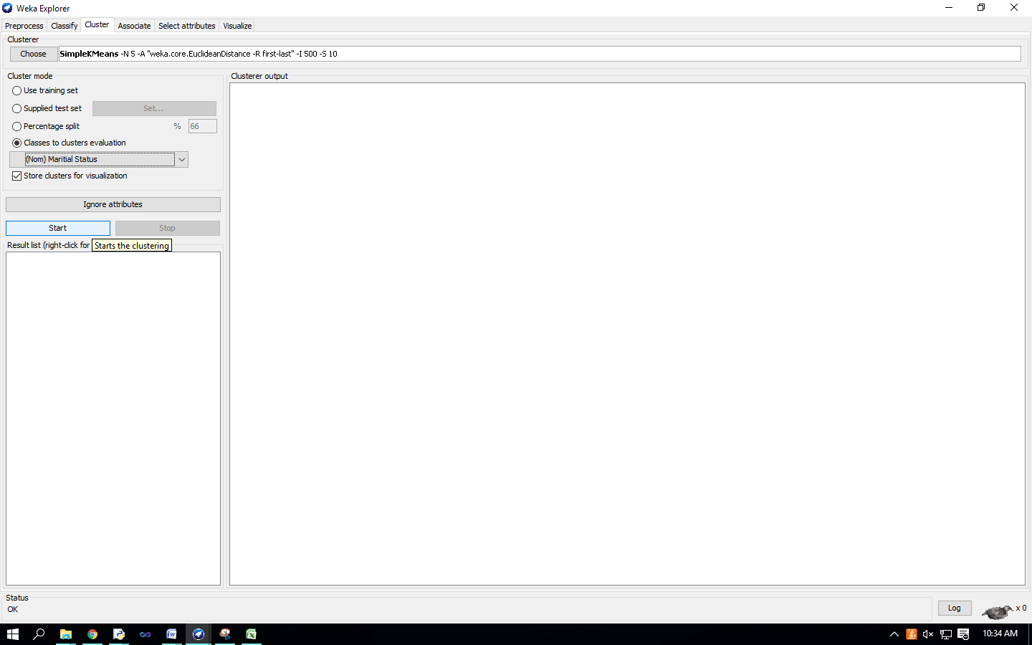

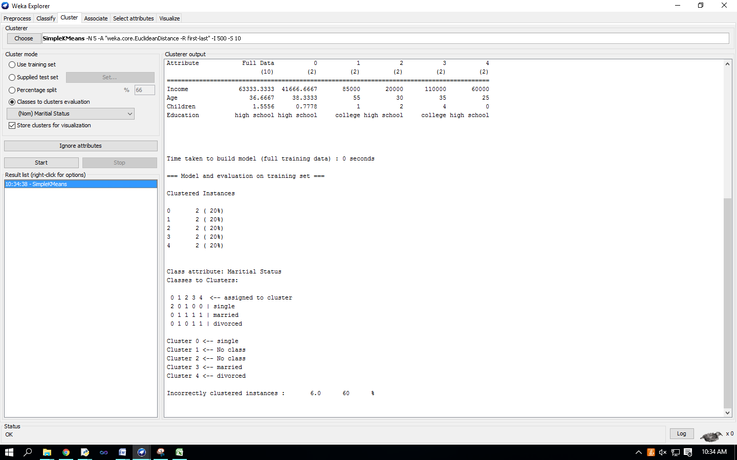

Right-click on the entry in the ‘Result list’ and select ‘Visualize cluster assignments’ in the pull-down window. 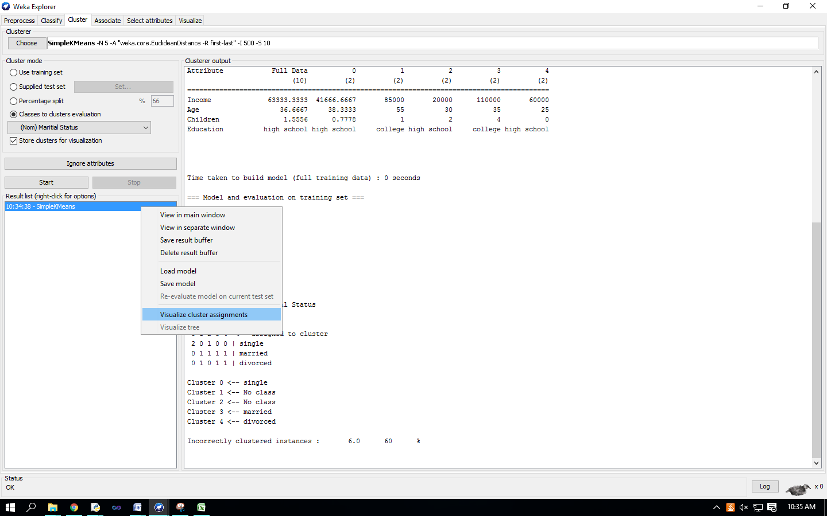 ‘Weka Clusterer Visualize’ window.

